1. HTTP GET to get all product’s available in the data store using <http://localhost:3000/products/>

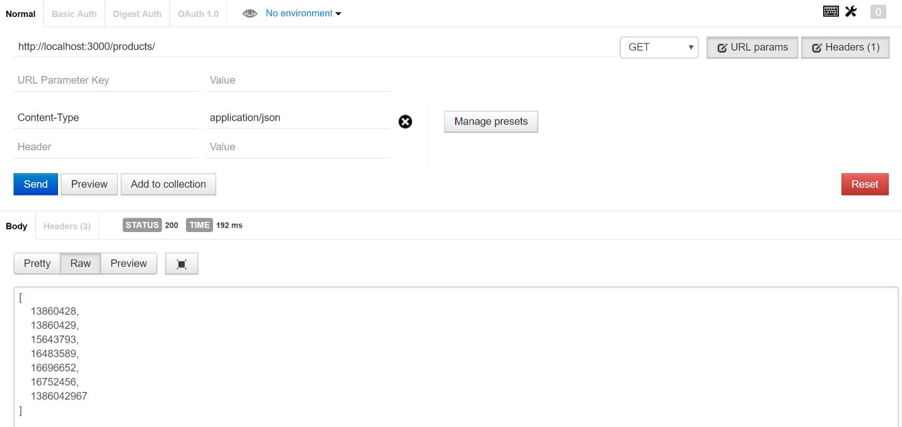

1. HTTP GET to get product information using <http://localhost:3000/products/13860428>
2. [For Success Scenario with valid product ID]

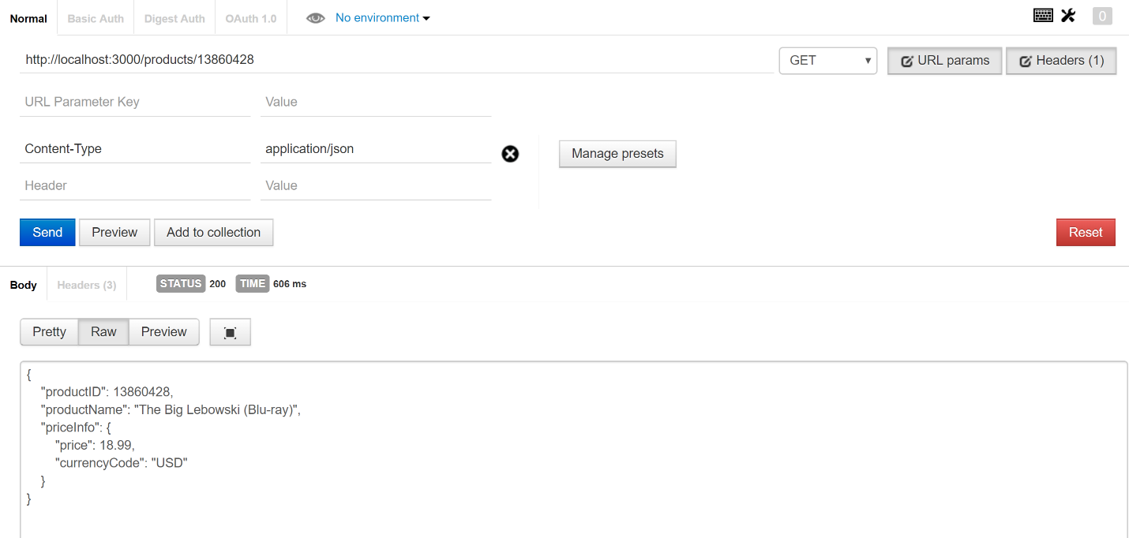

1. [For Invalid Product ID (0 or any negative number)]

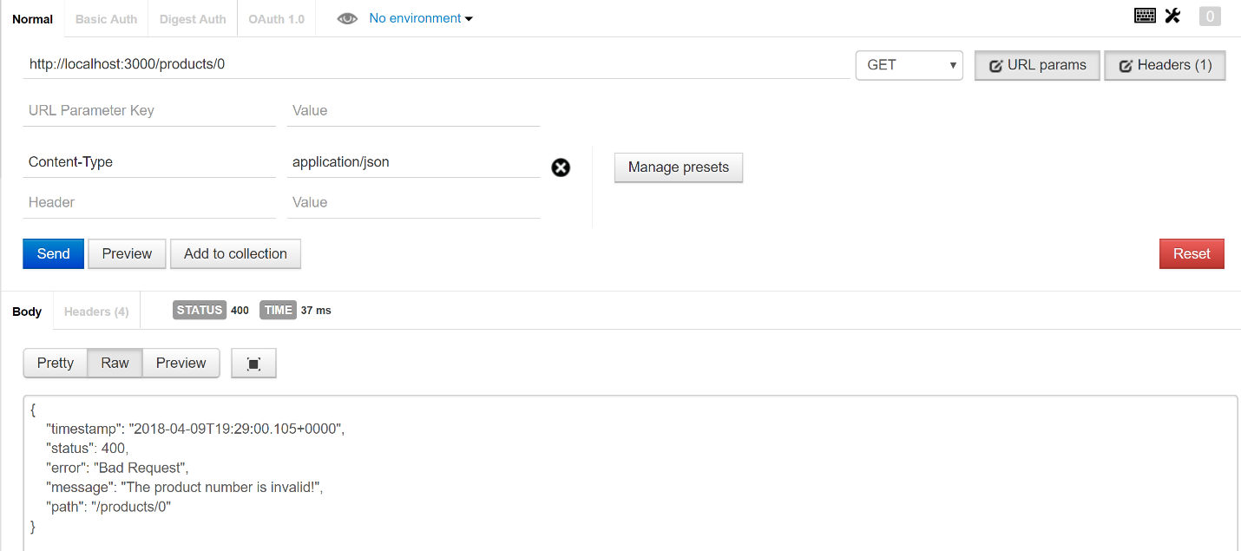

1. [If product ID or Product name not found]

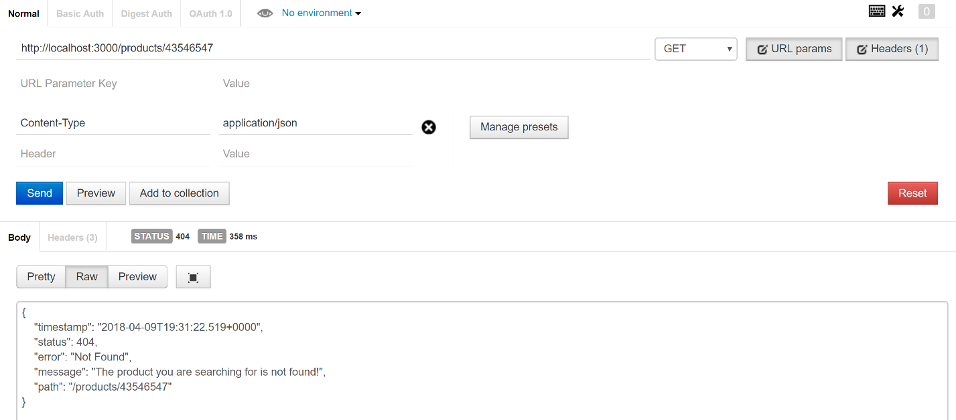

1. HTTP PUT request to update Product price using <http://localhost:3000/products/13860428>
2. [For success scenario]

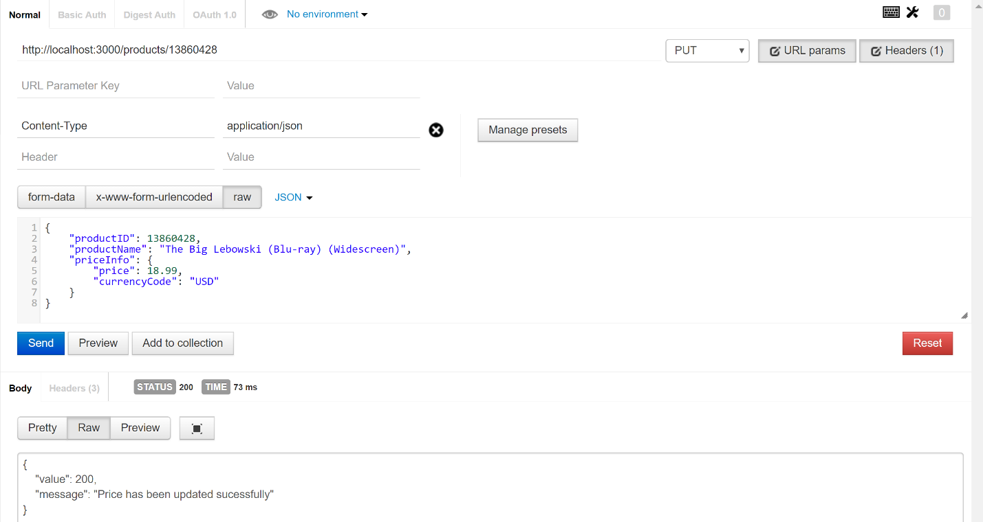

1. [If product ID in the URL and Request body doesn’t match]

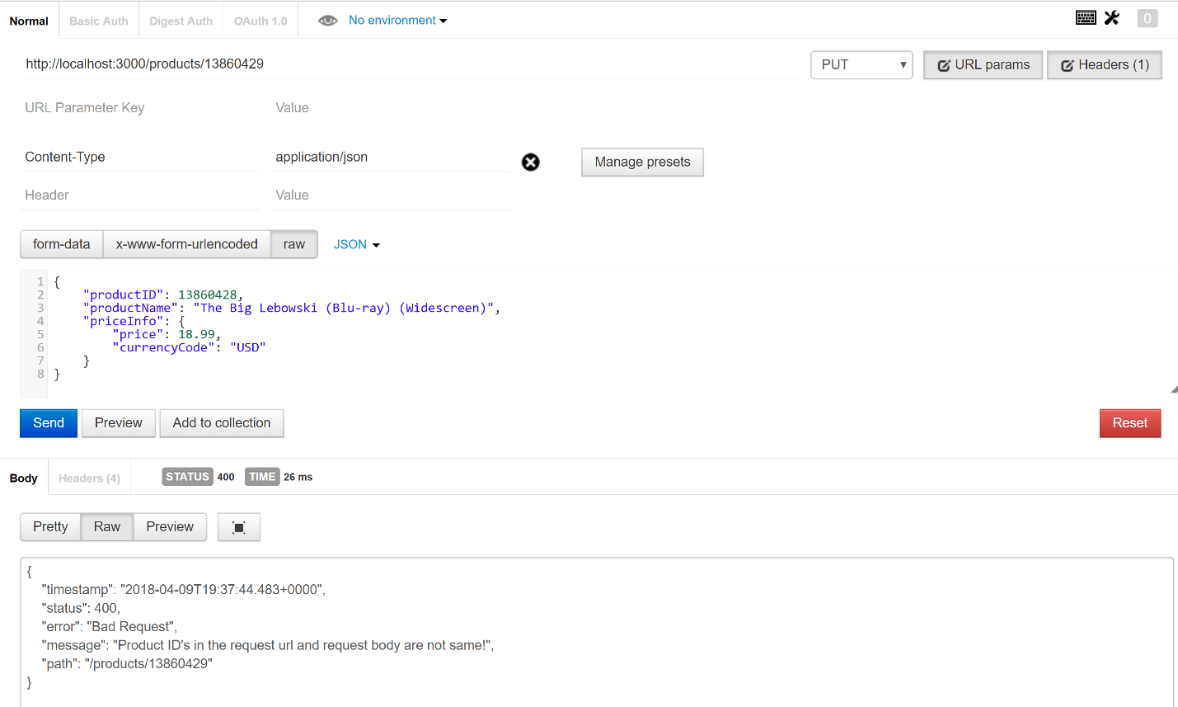

1. [If Product not found in data store]

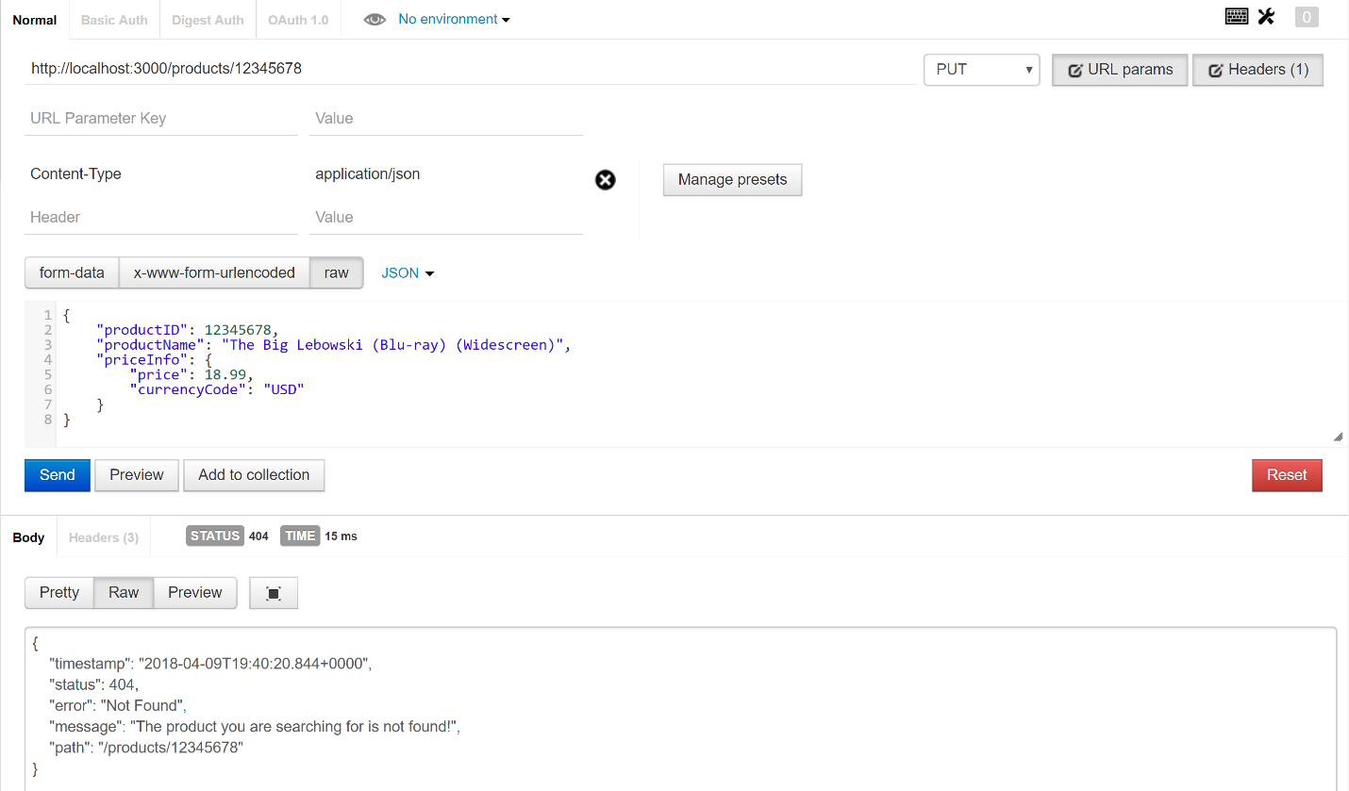

1. [If product ID is not valid]

